# CS 255 System Design Document Template

**Clay Duncan**

## Technical Requirements

The DriverPass system will require a cloud-based system so users can access practice test and schedule driving lessons with instructors. The system is a paid program which will require the customer a payment service for customers to purchase one of three packages to use the system. The system will require an internet connection and have two factor authorization for staff which will add an extra layer of security on top of the provided cloud security.

## UML Diagrams

### UML Use Case Diagram

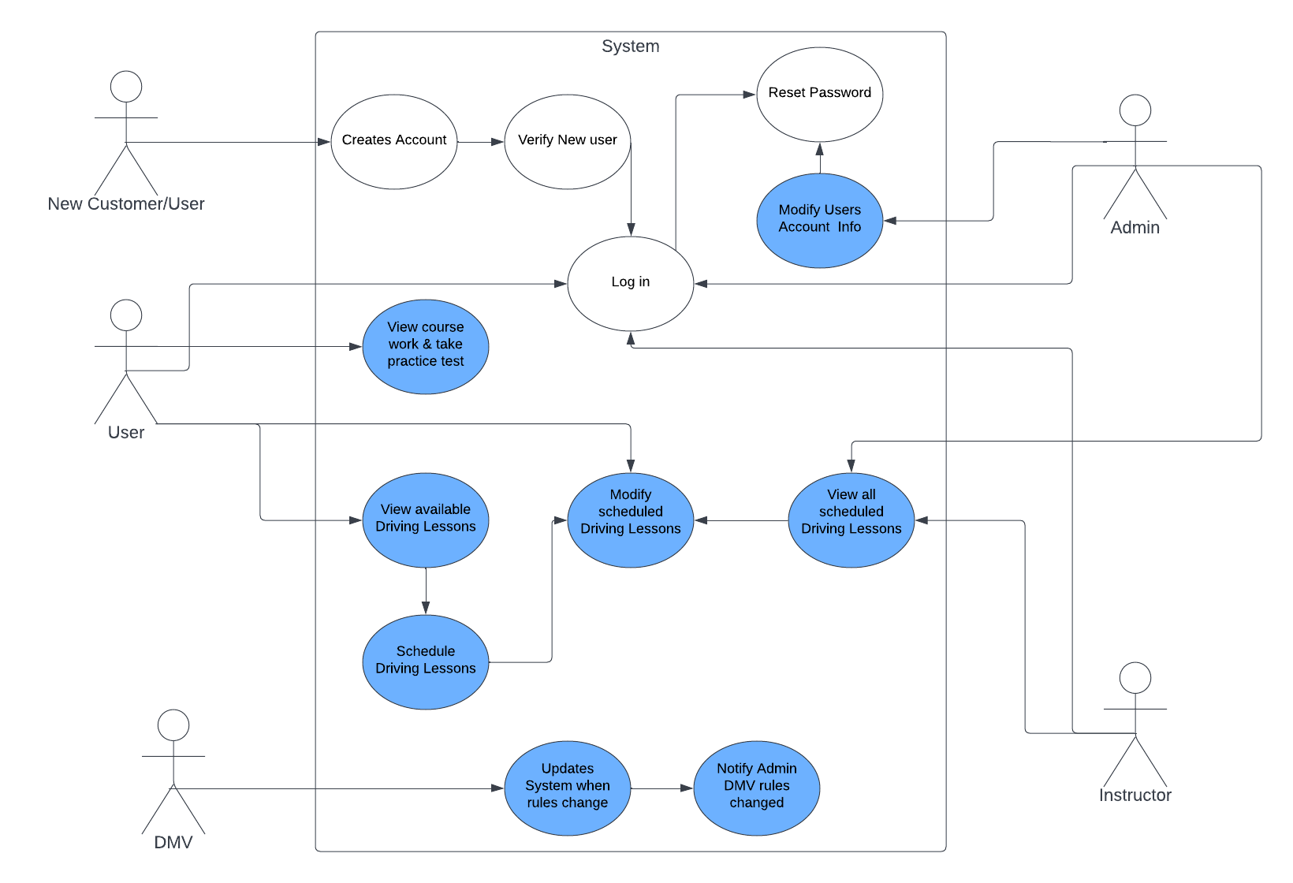

### UML Activity Diagrams

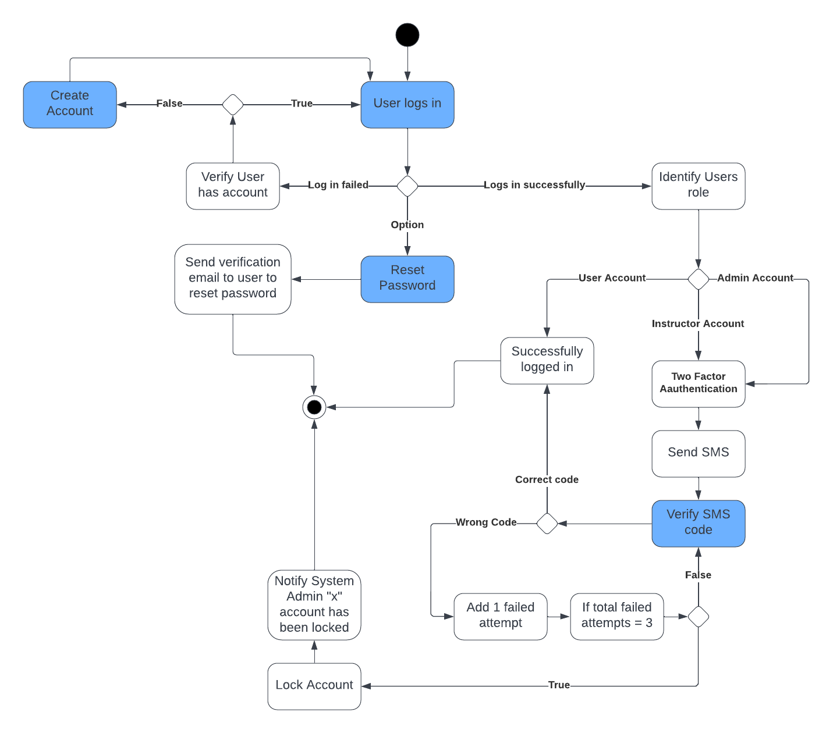**User Log In**

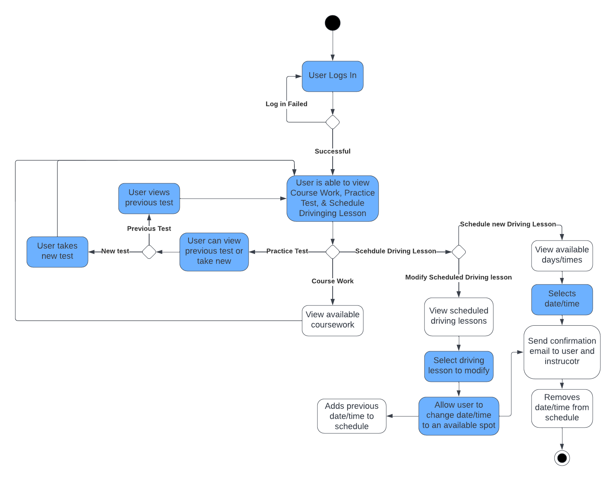**User Features**

### Sequence Diagram

### 

### UML Class Diagram